🎓 Nipracademy – Fee Structure & Course Details (Session 2026–27)
📍 Location: Deo, Aurangabad (Bihar)
🎯 Mission: “Village students ko city-level education dena, affordable fees ke saath.”

🧸 Pre-Primary (Nursery to UKG)
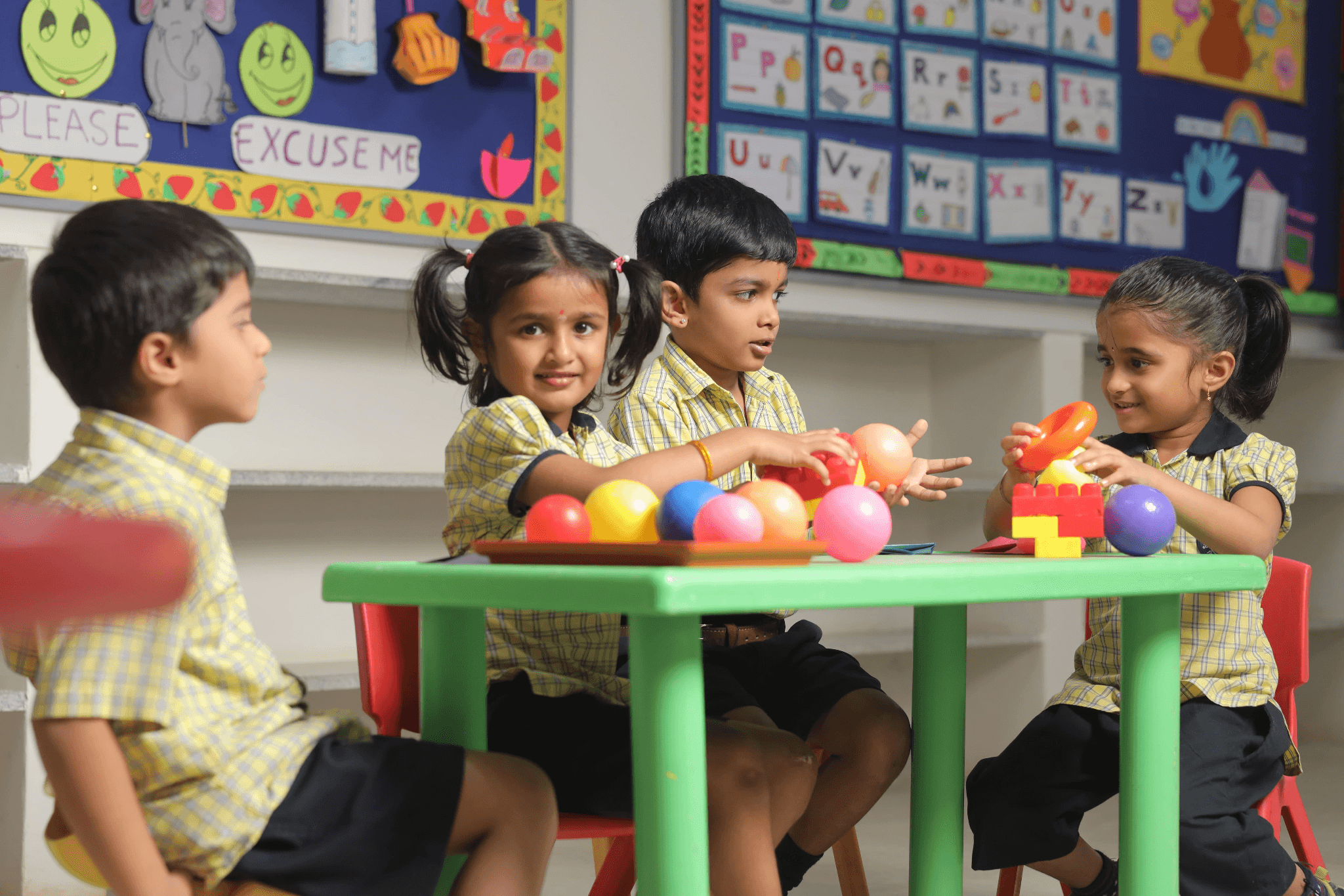
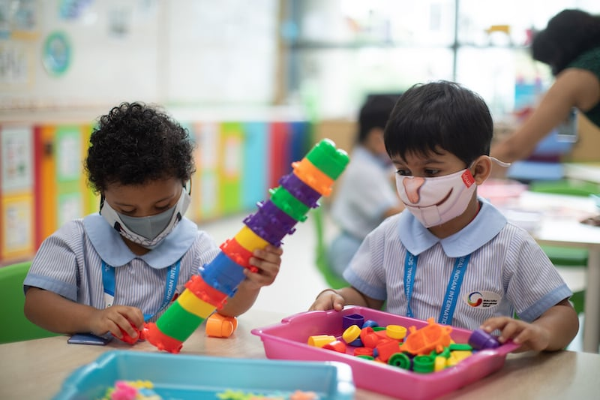
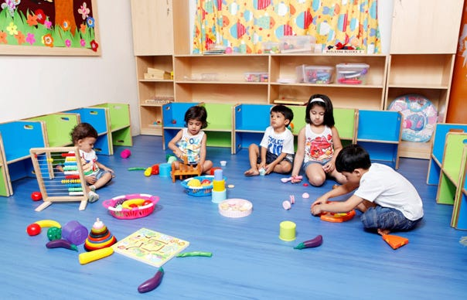
📚 Course Details:
- Basic English speaking & writing
- Hindi (letters & reading)
- Numbers (1–100), counting
- Drawing, activities & fun learning
- Behavior & communication development
💰 Fee Structure:
- Monthly Fee: ₹400 – ₹600
- Admission Fee: ₹50 (one-time)
🎯 Focus:
- Strong base building
- Learning with fun (no pressure)

NOTE : To begin your admission process, you only need to pay the admission fee at this stage.
Once the payment is completed, our executive will contact you shortly to guide you through the next steps, including course details, fee payment, and final admission confirmation.
This process is applicable for both online and offline batches.

📘 Primary (Class 1 to 5)

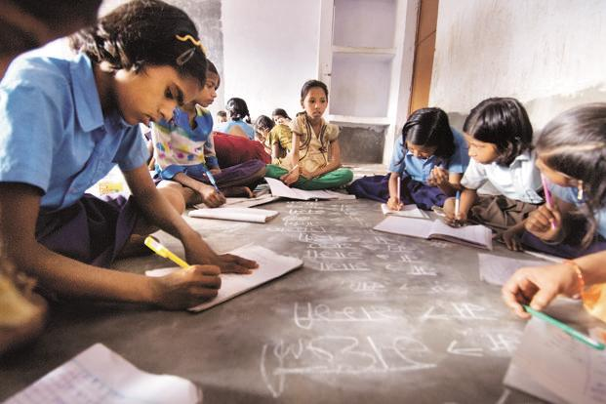

📚 Subjects:
- English
- Hindi
- Mathematics
- EVS / General Science
💰 Fee Structure:
- Monthly Fee: ₹400 – ₹600
- Admission Fee: ₹70
🎯 Focus:
- Concept clarity (basic strong karna)
- Reading & writing improvement
- Regular tests + homework support

NOTE : To begin your admission process, you only need to pay the admission fee at this stage.
Once the payment is completed, our executive will contact you shortly to guide you through the next steps, including course details, fee payment, and final admission confirmation.
This process is applicable for both online and offline batches.

📗 Middle School (Class 6 to 8)



📚 Subjects:
- Mathematics
- Science
- English
- Social Science (SST)
💰 Fee Structure:
- Monthly Fee: ₹500 – ₹8,00
- Admission Fee: ₹1,00
🎯 Focus:
- Strong concept building (future boards ke liye base)
- Weekly tests & performance tracking
- Doubt clearing sessions
NOTE : To begin your admission process, you only need to pay the admission fee at this stage.
Once the payment is completed, our executive will contact you shortly to guide you through the next steps, including course details, fee payment, and final admission confirmation.
This process is applicable for both online and offline batches.

📕 Secondary (Class 9 & 10 – Board Preparation)



📚 Subjects:
- Mathematics
- Science (Physics, Chemistry, Biology)
- English
- Social Science
💰 Fee Structure:
- Monthly Fee: ₹1,000 – ₹1,500
- Admission Fee: ₹1,50
🎯 Focus:
- Board exam preparation (Bihar Board + CBSE)
- Important questions & previous year papers
- Regular test series + answer writing practice
- Topper guidance & strategy

NOTE : To begin your admission process, you only need to pay the admission fee at this stage.
Once the payment is completed, our executive will contact you shortly to guide you through the next steps, including course details, fee payment, and final admission confirmation.
This process is applicable for both online and offline batches.

📙 Senior Secondary (Class 11 & 12)

🔬 Science Stream ( PCM/PCB/PCBM)

📚 Subjects:
- Physics
- Chemistry
- Mathematics / Biology
💰 Fee Structure:
- Monthly Fee: ₹1,500 – ₹2,500
- Admission Fee: ₹2,00
🎯 Focus:
- Deep concept clarity
- Numerical problem solving
- Board + competitive base preparation

NOTE : To begin your admission process, you only need to pay the admission fee at this stage.
Once the payment is completed, our executive will contact you shortly to guide you through the next steps, including course details, fee payment, and final admission confirmation.
This process is applicable for both online and offline batches.

📊 Commerce Stream

📚 Subjects:
- Accountancy
- Business Studies
- Economics
💰 Fee Structure:
- Monthly Fee: ₹1,200 – ₹2,000
- Admission Fee: ₹1,50
🎯 Focus:
- Concept + practical understanding
- Accounts practice & exam writing

NOTE : To begin your admission process, you only need to pay the admission fee at this stage.
Once the payment is completed, our executive will contact you shortly to guide you through the next steps, including course details, fee payment, and final admission confirmation.
This process is applicable for both online and offline batches.

📖 Arts / Humanities Stream

📚 Subjects:
- History
- Political Science
- Geography
- Other subjects
💰 Fee Structure:
- Monthly Fee: ₹1,000 – ₹1,800
- Admission Fee: ₹150
🎯 Focus:
- Theory clarity + answer writing
- Board-oriented preparation

🎁 Special Offers & Scholarships
- 👨‍👩‍👧 Sibling Discount: 10% off for second child
- 🏆 Merit Scholarship: 10–20% discount for toppers
- 👧 Girls Special Discount: Encouraging girl education
- 💸 Annual Payment Offer: 1 month fee FREE

📊 Why Choose Nipracademy?
- ✅ Experienced & dedicated teachers
- ✅ Small batch size (better attention)
- ✅ Regular tests & performance reports
- ✅ Doubt clearing sessions
- ✅ Focus on Bihar Board + CBSE both
- ✅ Proven results (Topper students)
- ✅ Affordable fees for village students

📞 Admission Open Now
📍 Location: Deo, Aurangabad (Bihar)
📢 Limited Seats – Enroll Now!

